LAPORAN PRAKTIKUM ETS


Nama : Arganta Bisma Pramata
NPM : 23081010291
Kelas : ROBOTIKA A081
Dosen Pengampu : Dr. Basuki Rahmat S.Si. MT

PROGRAM STUDI INFORMATIKA FAKULTAS ILMU KOMPUTER
UNIVERSITAS PEMBANGUNAN NASIONAL “VETERAN” JAWA TIMUR
2026

Uji Kit IMCLab Melalui Serial Arduino
Code On OFF Motor
int ledPin = 2; char myData = 0;
int motor1Pin1 = 27; int motor1Pin2 = 26; int enable1Pin = 12;

// Setting PWM properties const int freq = 30000; const int pwmChannel = 0; const int resolution = 8;
int dutyCycle = 200;

const byte pin_rpm = 13; int volatile rev = 0;
//int rpm = 0;
void setup()
{
pinMode(ledPin, OUTPUT); Serial.begin(115200);
// sets the pins pinMode(motor1Pin1, OUTPUT); pinMode(motor1Pin2, OUTPUT); pinMode(enable1Pin, OUTPUT);
pinMode(pin_rpm, INPUT_PULLUP);
// pinMode(pin_rpm, INPUT);
//attachInterrupt(digitalPinToInterrupt(pin_rpm), isr, RISING);
// configure LED PWM functionalitites ledcSetup(pwmChannel, freq, resolution);

// attach the channel to the GPIO to be controlled ledcAttachPin(enable1Pin, pwmChannel);

// testing
Serial.print("Testing DC Motor...");

}

void MotorOn()
{
// Motor On - Move DC motor forward dutyCycle = 205; digitalWrite(motor1Pin1, HIGH); digitalWrite(motor1Pin2, LOW);

ledcWrite(pwmChannel, dutyCycle);
}

void MotorOff()
{
dutyCycle = 0; digitalWrite(motor1Pin1, HIGH); digitalWrite(motor1Pin2, LOW); ledcWrite(pwmChannel, dutyCycle);
}

void loop()
{
myData = int(Serial.read());

if (myData == '1'){ Serial.println("LED is on !!!"); digitalWrite(ledPin, HIGH); MotorOn();
}
else if (myData == '0'){ Serial.println("LED is off !!!"); digitalWrite(ledPin, LOW); MotorOff();
}
}

Hasil Uji IMCLab Melalui Arduino

ON

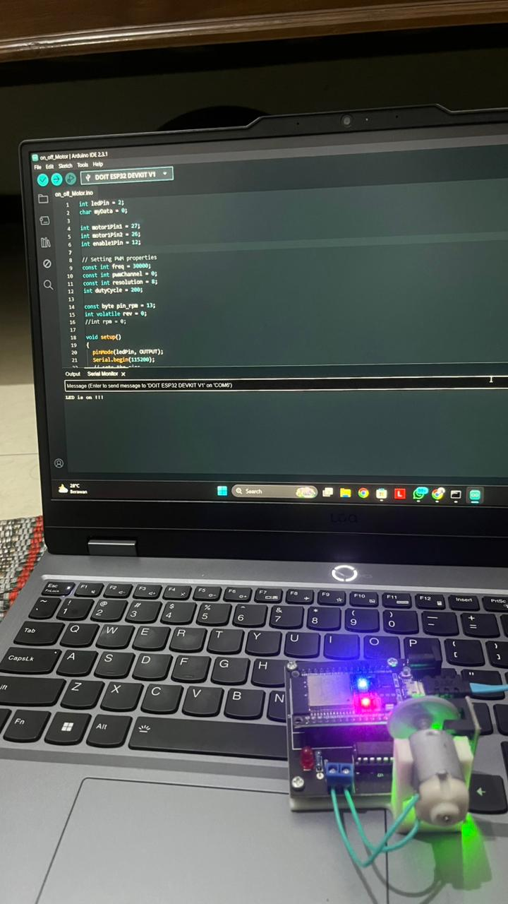

OFF

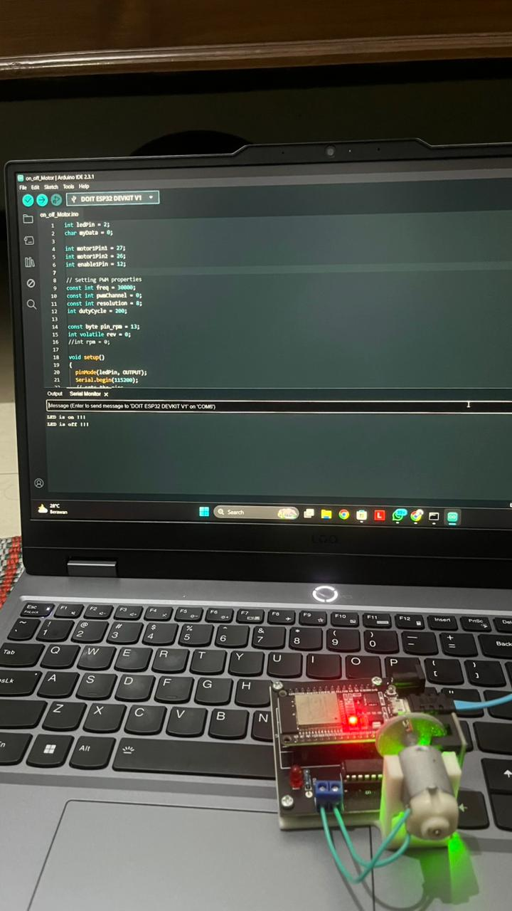
Uji Kit IMCLab Melalui Jupyter Pyhton Code Test Port Serial
import serial
#arduinoData = serial.Serial('/dev/ttyACM1', 9600) arduinoData = serial.Serial('COM6', 115200, timeout=0)
while True:
myData = input('Kirimkan perintah (1/0): ') if myData == "1":
arduinoData.write(b'1') elif myData == "0":
arduinoData.write(b'0')

Code Imc Lab.py
import serial
import serial.tools.list_ports import time
class iMCLab:
def init (self, port=None, baudrate=115200):
# Jika port tidak diisi, program akan mencari otomatis if port is None:
ports = list(serial.tools.list_ports.comports()) for p in ports:
# Mencari perangkat USB/Arduino/ESP32
if 'USB' in p.description or 'CH340' in p.description or 'CP210' in p.description: port = p.device
break

try:
self.ser = serial.Serial(port, baudrate, timeout=1)
time.sleep(2) # Memberi waktu ESP32 untuk reset setelah koneksi print(f"Opening connection")
print(f"iMCLab connected via Arduino on port {port}") except Exception as e:
print(f"Gagal koneksi: {e}")
def LED(self, value):
# Mengirim perintah ke ESP32 dalam format 'LED:nilai' if self.ser.is_open:
command = f"LED:{value}\n" self.ser.write(command.encode())
else:
print("Error: Koneksi serial tertutup.")

def version(self):
return "iMCLab Library v1.0 - UPN Veteran Jatim"

def close(self):
if self.ser.is_open: self.ser.close()
print("Arduino disconnected successfully") return True
return False

Hasil Uji Lab Melalui Jupyter Python
ON

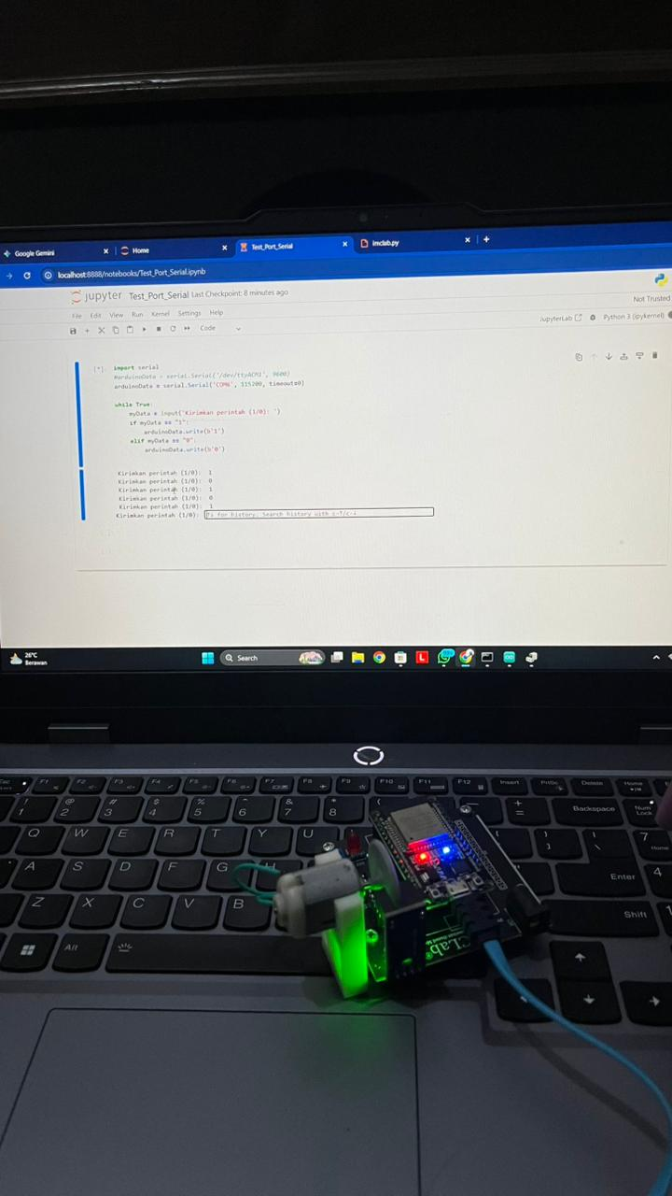

OFF

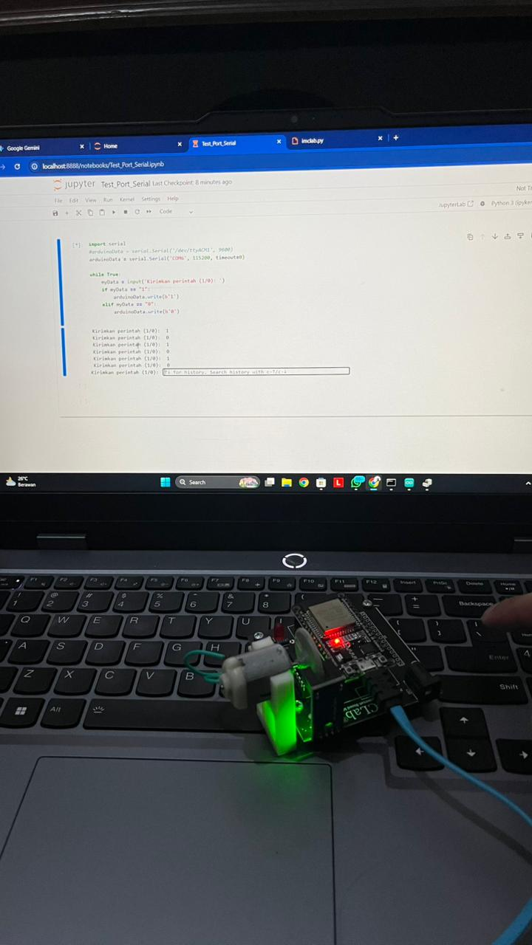
Uji Kit IMCLab Melalui Hp Dengan IOT Code IOT IMCLab
#include <WiFi.h> #include <PubSubClient.h> #include <Arduino.h>

int ledPin = 2; char myData = 0;

int motor1Pin1 = 27; int motor1Pin2 = 26; int enable1Pin = 12;

// Setting PWM properties const int freq = 30000; const int pwmChannel = 0; const int resolution = 8;
int dutyCycle = 200;

const byte pin_rpm = 13; int volatile rev = 0;
//int rpm = 0;

const char* ssid = "PROBORINI"; // Enter your WiFi name const char* password = "sudirjop"; // Enter WiFi password
#define mqttServer "broker.emqx.io" #define mqttPort 1883

WiFiServer server(80); WiFiClient espClient; PubSubClient client(espClient);

String Topic; String Payload;
// constants
const int baud = 115200; // serial baud rate

void setup()
{
pinMode(ledPin, OUTPUT); Serial.begin(115200);
// sets the pins pinMode(motor1Pin1, OUTPUT); pinMode(motor1Pin2, OUTPUT); pinMode(enable1Pin, OUTPUT);
pinMode(pin_rpm, INPUT_PULLUP);
// pinMode(pin_rpm, INPUT);

//attachInterrupt(digitalPinToInterrupt(pin_rpm), isr, RISING);

// configure LED PWM functionalitites ledcSetup(pwmChannel, freq, resolution);

// attach the channel to the GPIO to be controlled ledcAttachPin(enable1Pin, pwmChannel);

// testing
Serial.print("Testing DC Motor...");
// Connect to WiFi network Serial.println(); Serial.println(); Serial.print("Connecting to "); Serial.println(ssid); WiFi.begin(ssid, password);

while (WiFi.status() != WL_CONNECTED) { delay(500);
Serial.print(".");
}
Serial.println(""); Serial.println("WiFi connected");

// Connect to Server IoT (CloudMQTT) client.setServer(mqttServer, mqttPort); client.setCallback(receivedCallback);

while (!client.connected()) { Serial.println("Connecting to CLoud IoT ...");
// if (client.connect("ESP32Client", mqttUser, mqttPassword )) { if (client.connect("iMCLab On/Off")) {

Serial.println("connected"); Serial.print("Message received: ");
} else {
Serial.print("failed with state "); Serial.print(client.state()); delay(2000);
}
client.subscribe("kontrolmyy");
}
}

void MotorOn()
{
// Move DC motor forward with increasing speed

dutyCycle = 205; digitalWrite(motor1Pin1, HIGH); digitalWrite(motor1Pin2, LOW); ledcWrite(pwmChannel, dutyCycle);
}

void MotorOff()
{
dutyCycle = 0; digitalWrite(motor1Pin1, HIGH); digitalWrite(motor1Pin2, LOW); ledcWrite(pwmChannel, dutyCycle);
}
void receivedCallback(char* topic, byte* payload, unsigned int length) {

/* we got '1' -> MotorOn() */ if ((char)payload[0] == '1') {
MotorOn(); Serial.println("Motor On");
}

/* we got '0' -> Motoroff */
if ((char)payload[0] == '0') { MotorOff(); Serial.println("Motor Off");
}
}

void loop()
{

client.loop();
myData = int(Serial.read()); if (myData == '1'){
Serial.println("LED is on !!!"); digitalWrite(ledPin, HIGH); MotorOn();
}
else if (myData == '0'){ Serial.println("LED is off !!!"); digitalWrite(ledPin, LOW); MotorOff();
}

}

Hasil Uji IMCLab Melalui HP Dengan IOT

ON

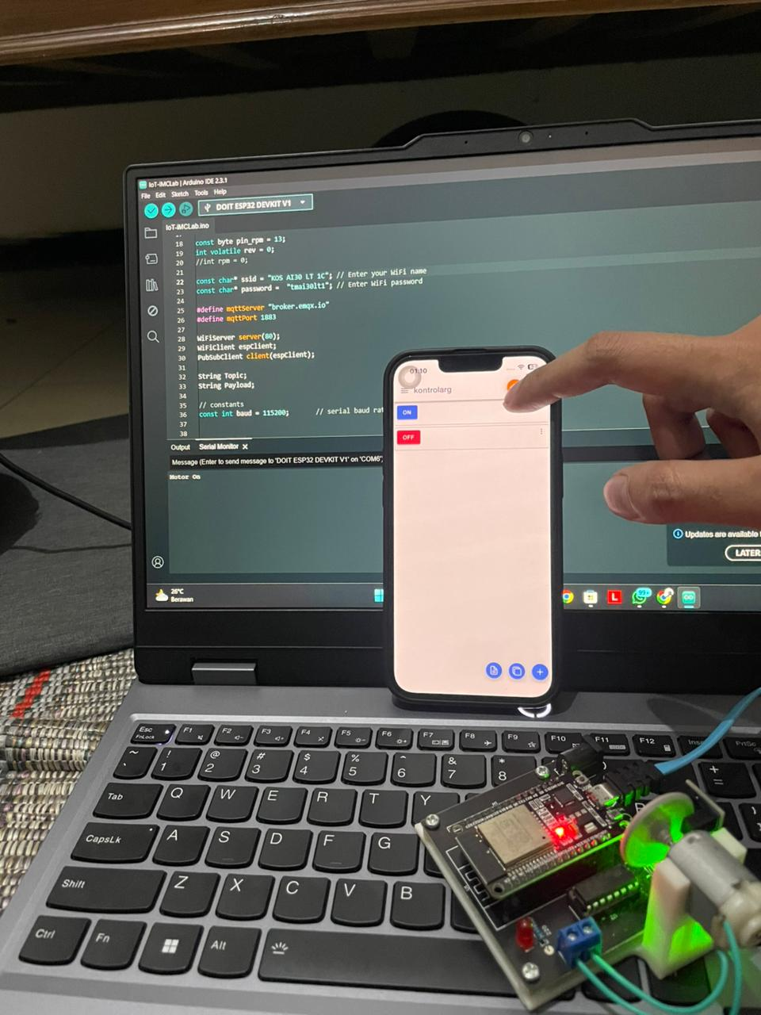

OFF

